Federated Traffic Sign Recognition under Non-IID Label Distributions: A Reproducible Study of FedAvg and FedProx
Ma He
Summer Research Workshop 2026 , City University of Hong Kong

Abstract
Federated learning enables multiple clients to train a shared model without transferring raw data to a central server, but heterogeneous client data can reduce global performance. This study investigates the effect of label-distribution skew on federated traffic-sign recognition and evaluates whether FedProx can reduce the resulting degradation. Experiments used the 43-class GTSRB dataset with five simulated clients. Centralized, local-only, and IID FedAvg baselines were first established. Dirichlet partitions with α = 10, 1.0, 0.5, and 0.1 then created increasing levels of label heterogeneity. Under IID, FedAvg achieved 92.60% test accuracy and 89.44% macro-class accuracy. Performance remained stable under mild and moderate skew, but at α = 0.1, test accuracy fell to 71.49% and macro-class accuracy to 69.42%, with several zero-accuracy classes. In strictly matched FedProx experiments, changing μ from 0 to 0.1 increased test accuracy from 77.51% to 84.52% and macro-class accuracy from 73.60% to 80.79% at α = 0.1; both metrics also improved at α = 0.5. The results show that FedAvg is robust to limited label heterogeneity, while proximal regularisation can partially mitigate stronger skew. The conclusions are limited by one random seed, five fully participating clients, and one local epoch per round.

1 Introduction
Traffic-sign recognition is an important perception task in intelligent transportation and automated-driving systems. A vehicle must identify speed limits, warnings, prohibitions, and mandatory signs before this information can support safe decision-making. Training accurate recognition models usually requires data collected from many vehicles and locations. However, centrally collecting road images may create privacy, ownership, storage, and communication concerns. Federated learning offers an alternative approach: clients keep their images locally, train a shared model through local computation, and send model updates rather than raw data to a server [1].

A central difficulty is that client data are rarely independent and identically distributed. Vehicles travelling on different roads, in different cities, or at different times may observe very different traffic-sign categories. One client may contain many speed-limit signs, while another may contain mostly warning or prohibition signs. This label-distribution skew can make local optimisation directions inconsistent. When these updates are averaged by FedAvg, the global model may become biased towards categories that dominate particular clients. Overall accuracy may also hide this problem because frequent classes contribute more test samples than rare classes. Macro-class accuracy and per-class analysis are therefore needed to detect class-level degradation.

FedProx was proposed to address statistical and systems heterogeneity by adding a proximal term to each client’s local objective [2]. This term penalises excessive movement away from the current global model. In principle, it may reduce local overfitting and client drift when data distributions differ. However, its effect must be evaluated with a matched control. Comparing FedProx with a FedAvg run that uses a different optimiser, learning rate, or initialisation would not isolate the contribution of the proximal term.

This study examines federated traffic-sign classification on GTSRB using five simulated clients [3]. It asks three questions: whether FedAvg provides a reliable IID baseline; how its overall and class-level performance changes as Dirichlet label skew becomes stronger; and whether FedProx improves performance under strong skew when all other training conditions are fixed. The study contributes a reproducible experimental pipeline, a controlled heterogeneity analysis across four Dirichlet settings, and strictly paired comparisons between μ = 0 and μ = 0.1. Rather than treating all Non-IID data as equally harmful, the report identifies the conditions under which FedAvg remains robust and the conditions under which proximal regularisation becomes beneficial.

2 Methodology
Figure 1 summarises the overall federated-learning workflow used throughout the study.
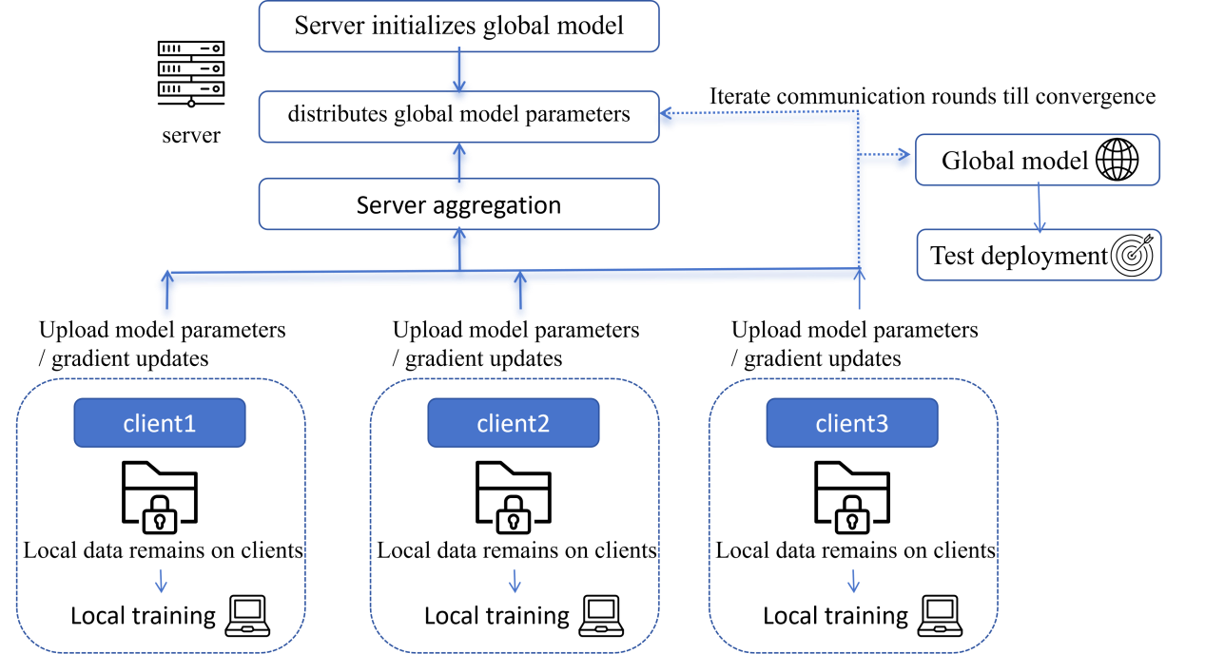
Figure 1. Overall federated-learning workflow used in this study.

2.1 Dataset and Client Partitions
Experiments used the German Traffic Sign Recognition Benchmark (GTSRB), containing 39,209 training images and 12,630 official test images across 43 classes. Images were decoded as RGB, resized to 32×32, converted to float32, and normalised to [0,1]. Horizontal flipping was not used because it can change the meaning of directional traffic signs. The official test set was excluded from client partitioning and hyperparameter selection.
Five simulated clients were created using a fixed seed of 20260720. The IID baseline used class-stratified partitioning, giving every client all 43 classes and a similar number of samples. For the Non-IID experiments, each class was distributed across clients according to a symmetric Dirichlet distribution:
$$P_{c} \sim Dirichlet(α,...,α)$$
The values α=10, 1.0, 0.5, and 0.1 represented increasing label heterogeneity. Smaller values concentrated individual classes on fewer clients. Each partition was saved as fixed client CSV files and reused across algorithms rather than being resampled during comparison.

2.2 Model and FedAvg Baselines
All main experiments used the same convolutional neural network without Batch Normalization:
Figure 2. CNN architecture used for GTSRB classification in all main experiments.

Batch Normalization was excluded because earlier experiments showed that its moving statistics were not correctly maintained in the federated pipeline.

The IID study compared centralized training, Local-only training, and weighted FedAvg. Centralized training placed all training data in one pipeline with an internal validation split. Local-only training produced one independent model per client without parameter aggregation. FedAvg weighted each client contribution according to its number of local training examples.

Stage 1A and Stage 1B FedAvg used all five clients in every round, one local epoch, batch size 64, client-side Adam with learning rate 0.001, a server learning rate of 1.0, and 160 communication rounds.

2.3 Strictly Paired FedProx Experiments
FedProx adds a proximal term to each client’s local objective:
$$ℒ_{k}(w)=ℒ_{task, k}(w)+\frac{μ}{2}||w−w^{t}||_{2}^{2}$$
where $w^{t}$ is the global model received at the beginning of the communication round. When $μ$=0, the proximal term disappears, creating a FedAvg-equivalent control within the same trainer.

Formal FedProx experiments were conducted on the α=0.1 and α=0.5 partitions. Each partition compared $μ$=0 with $μ$=0.1, while fixing the initial model, client data, client order, optimiser, learning rate, server update, training budget, and evaluation procedure.

Both configurations used client-side SGD with learning rate 0.1 and zero momentum, server learning rate 1.0, five of five clients per round, one local epoch, batch size 64, and 160 rounds. Learning-rate and $μ$ screening used only global validation results. The official test set was evaluated only after the parameters had been frozen.

2.4 Evaluation and Reproducibility
Ten percent of each client partition was reserved for validation, and these subsets were combined for global model selection. The checkpoint with the highest global validation accuracy was used for final testing.

Reported metrics included test accuracy, test loss, macro-class accuracy, per-class accuracy, confusion matrices, and learning curves. Macro-class accuracy gave equal weight to all 43 classes and was therefore used to identify class-level degradation that might be hidden by overall accuracy.

The pipeline saved experimental configurations, per-round metrics, best and final checkpoints, and test outputs. Additional checks verified that paired experiments used fixed partitions and identical Round-0 model weights, that model updates remained finite, that interrupted training could be resumed continuously, and that server aggregation was correctly weighted by client sample counts. Because all formal results used one random seed, confidence intervals and statistical significance tests were not reported.

3 Results and Analysis

3.1 IID Baseline Performance
The IID experiment first examined whether the federated pipeline could learn a reliable global traffic-sign classifier. Table 1 compares centralized training, independent Local-only training, and FedAvg.
Table 1. Performance under the IID partition
Method | Test Accuracy | Macro Class Accuracy
Centralized | 91.16% | 88.44%
Local-only Mean | 60.11% | 49.67%
FedAvg | 92.60% | 89.44%
The five independently trained Local-only models achieved a mean test accuracy of 60.11% and a mean macro-class accuracy of 49.67%. Their weaker performance indicates that one client’s data were insufficient for learning a model that generalised well across the complete official test set.

FedAvg achieved 92.60% test accuracy and 89.44% macro-class accuracy, which were close to the centralized results and substantially higher than the Local-only averages. This confirms that parameter aggregation successfully combined information from the five clients without collecting their original images on a central training server.

FedAvg slightly exceeded the centralized model in this experiment. However, this difference should not be interpreted as evidence that federated training was inherently superior. The two settings used different training budgets: centralized training used 30 epochs, whereas FedAvg used 160 communication rounds with one local epoch per round. The appropriate conclusion is therefore that the fully trained FedAvg model achieved performance comparable to centralized training under the evaluated configurations.

3.2 Effect of Label Heterogeneity on FedAvg
Figure 3 illustrates the difference between the α=10 and α=0.1 client partitions. Under α=10, most classes were distributed relatively evenly across the five clients. Under α=0.1, individual classes were concentrated on a small number of clients, while other clients contained few or no examples of those classes.
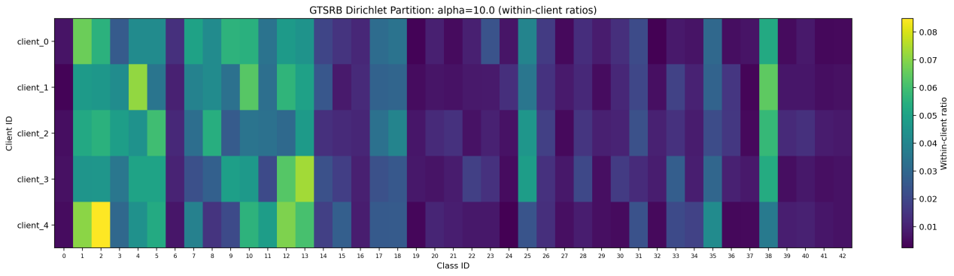
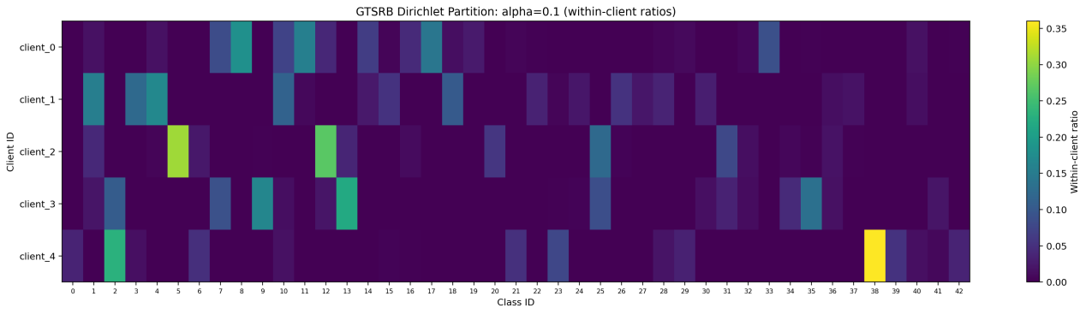
Figure 3. Client-level class distributions under mild and extreme label heterogeneity
(Larger Dirichlet α produces a more balanced distribution, whereas α=0.1 concentrates individual classes on a small number of clients.)
Table 2. FedAvg performance across Dirichlet partitions
Partition | Mean JS | Test Accuracy | Macro Class Accuracy
IID | 0.0000 | 92.60% | 89.44%
α = 10 | 0.0085 | 92.39% | 89.38%
α = 1.0 | 0.0880 | 92.60% | 89.49%
α = 0.5 | 0.1338 | 91.77% | 87.27%
α = 0.1 | 0.3148 | 71.49% | 69.42%
FedAvg remained stable under the α=10 and α=1.0 partitions. Their test and macro-class accuracies were close to the IID baseline, showing that moderate differences between client label distributions did not necessarily produce substantial performance degradation.

At α=0.5, test accuracy decreased by only 0.83 percentage points relative to IID, while macro-class accuracy decreased by 2.17 percentage points. The larger decline in the macro-class metric suggests that class-level imbalance began to appear before overall accuracy changed substantially.

The strongest degradation occurred at α=0.1. Test accuracy fell to 71.49%, approximately 21.12 percentage points below the IID result, while macro-class accuracy fell to 69.42%. Classes 0, 8, 19, 38, and 39 achieved zero accuracy, and the confusion matrix showed repeated errors between particular class pairs. The failure was therefore systematic rather than a small uniform reduction across all classes.
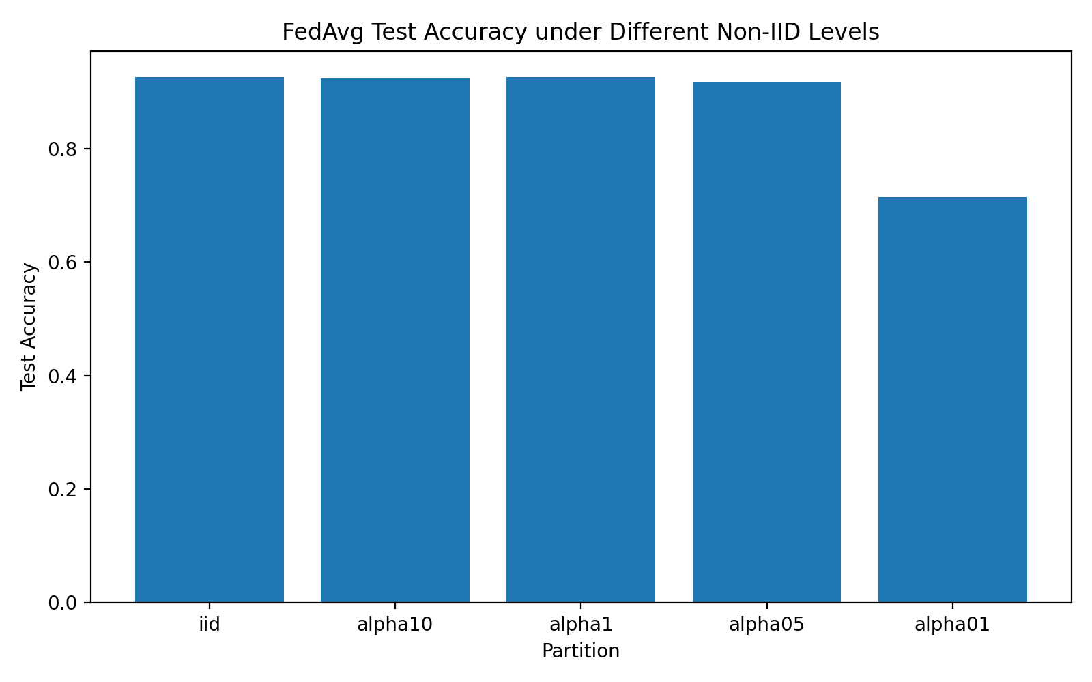
Figure 4. FedAvg test accuracy under different levels of label heterogeneity
(Performance remains stable under mild and moderate skew but drops sharply under the extreme α=0.1 partition.)
These results show that FedAvg did not fail simply because client data were Non-IID. Under five-client full participation and one local epoch, it tolerated limited label skew but had a clear robustness boundary under the most extreme partition.

3.3 Strictly Paired FedProx Results
FedProx was evaluated using μ=0 as the matched control and μ=0.1 as the proximal configuration. The comparison was performed separately from the historical Stage 1B Adam results because the paired experiments used client-side SGD. This design isolated the effect of the proximal term within the same trainer.
Table 3. Strictly paired FedProx results
Partition | Configuration | Test Accuracy | Macro-class Accuracy | Test Loss
α=0.1 | μ=0 | 77.51% | 73.60% | 0.7233
α=0.1 | μ=0.1 | 84.52% | 80.79% | 0.5331
α=0.5 | μ=0 | 87.36% | 82.46% | 0.4941
α=0.5 | μ=0.1 | 91.81% | 87.80% | 0.3461
Under α=0.1, changing μ from 0 to 0.1 increased test accuracy by 7.02 percentage points and macro-class accuracy by 7.19 percentage points. Test loss decreased from 0.7233 to 0.5331. Under α=0.5, test accuracy increased by 4.46 percentage points, macro-class accuracy increased by 5.35 percentage points, and test loss also decreased.

The improvement was larger under the more heterogeneous α=0.1 partition. This result is consistent with the expectation that restricting excessive local movement becomes more useful when client objectives differ more strongly.

3.4 Convergence and Class-level Changes
Figure 5 compares the validation-accuracy curves for the strictly paired α=0.1 experiments.
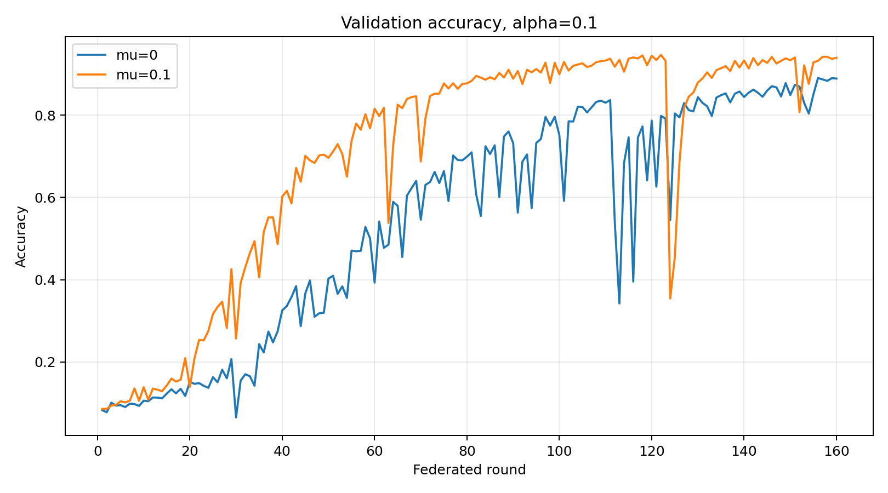
Figure 5. Validation accuracy of the strictly paired FedProx experiments under α=0.1
(The μ=0.1 configuration generally achieves faster improvement and higher validation accuracy than the μ=0 control.)
The μ=0.1 model achieved a best validation accuracy of 94.64%, compared with 89.02% for μ=0. Although both curves fluctuated, the proximal configuration generally maintained higher validation performance after the middle stage of training.

Per-class analysis showed that the improvement was not limited to a small number of frequent classes. Under α=0.1, 33 of the 43 classes improved, nine declined, and one remained unchanged. Under α=0.5, 32 classes improved, six declined, and five were unchanged.
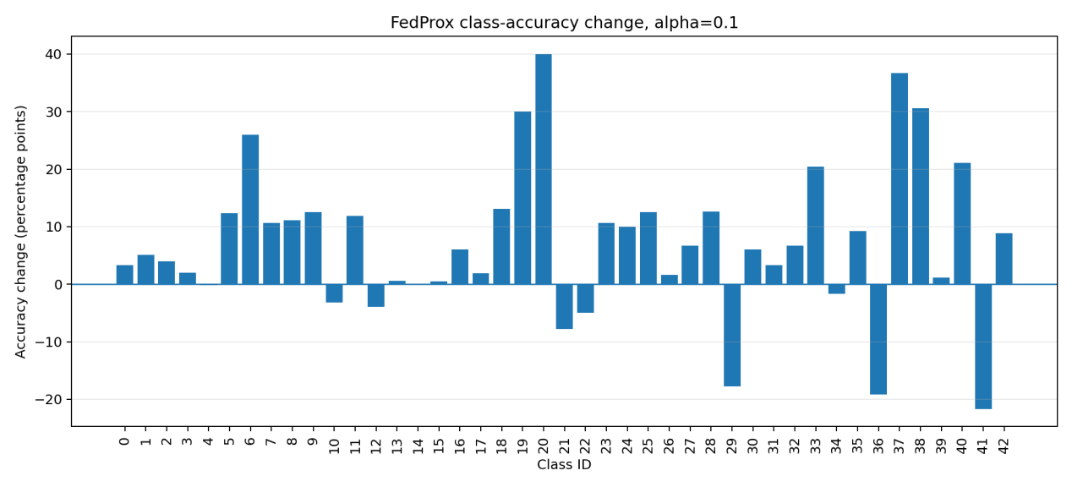
Figure 6. Per-class accuracy changes produced by μ=0.1 relative to the μ=0 control under α=0.1. (Positive bars indicate class-level improvement, while negative bars show that FedProx does not benefit every class equally.)
The predominance of positive class-level changes supports the increase in macro-class accuracy. However, several classes still deteriorated, and class 0 improved only from 0% to 3.33%. FedProx therefore reduced the severity of class-level degradation but did not eliminate it.

3.5 Summary of Findings
The experiments produced three main findings. First, FedAvg provided a strong IID baseline and greatly outperformed independent Local-only training. Second, FedAvg remained robust under mild and moderate label skew but suffered severe overall and class-level degradation under α=0.1. Third, the strictly matched FedProx configuration improved test accuracy, macro-class accuracy, and test loss under both evaluated Non-IID settings, with the larger benefit occurring under stronger heterogeneity.
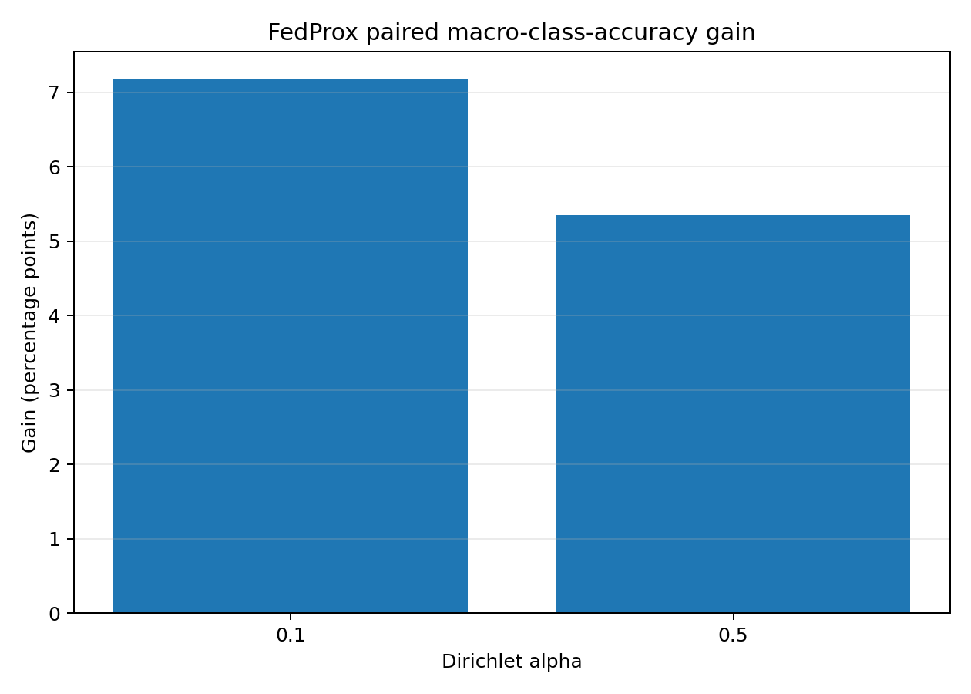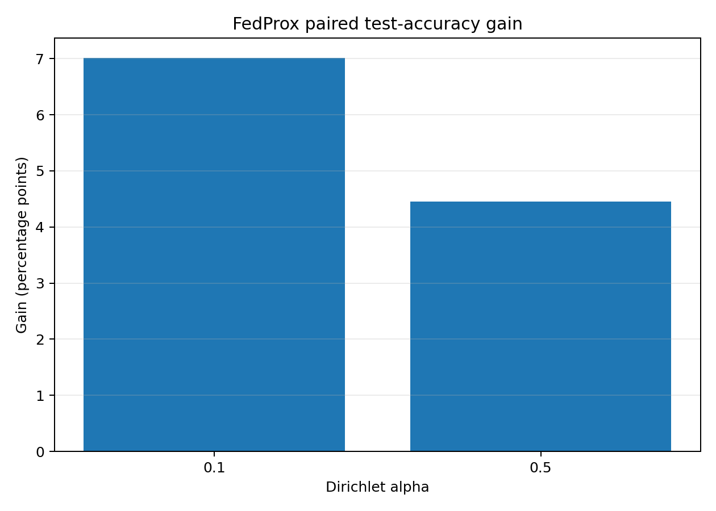
Figure 7. Paired gains from FedProx under two levels of label heterogeneity.
(The improvement is larger under the more extreme α=0.1 partition for both overall test accuracy and macro-class accuracy.)

4 Discussion
The results show that Non-IID data should not be treated as a single condition with a simple successful-or-failed outcome. Under the present setting of five clients, full client participation, and one local epoch per round, FedAvg remained effective under mild and moderate label skew. Performance only deteriorated sharply under the most extreme α=0.1 partition. This suggests that the practical effect of client heterogeneity depends not only on whether data are Non-IID, but also on the strength of the skew and the training configuration.

The difference between overall accuracy and macro-class accuracy was also important. At α=0.5, overall test accuracy decreased only slightly, while macro-class accuracy showed a larger decline. Under α=0.1, several classes reached zero accuracy. These findings indicate that overall accuracy can hide substantial class-level failure, particularly when the test set is imbalanced. For a traffic-sign task, this matters because a low-frequency class may still represent an important safety-related sign. Reporting macro-class and per-class performance therefore provides a more complete assessment than overall accuracy alone.

The FedProx results should be interpreted through the strictly matched comparison rather than through the historical Stage 1B FedAvg values. Because the Stage 1B experiments used Adam while the FedProx experiments used SGD, directly comparing them would mix the effect of the algorithm with the effect of the optimiser. By comparing μ=0 and μ=0.1 within the same trainer, the present study isolated the contribution of the proximal term more clearly. The consistent improvement in test accuracy, macro-class accuracy, and loss under both α=0.1 and α=0.5 supports the value of proximal regularisation in the evaluated settings.

The larger gain under α=0.1 is consistent with the purpose of FedProx. When clients contain very different class distributions, local training can move models towards different objectives. The proximal term restricts excessive movement away from the current global model and may therefore reduce conflicting client updates. However, this mechanism should not be overstated. The current experiments do not prove that FedProx reduced client drift in every round, and the improvement was not uniform across all classes.

An additional engineering lesson came from the earlier Batch Normalization experiments. High local accuracy was accompanied by near-random global performance because non-trainable BatchNorm statistics were not correctly maintained in the federated pipeline. This was an implementation issue rather than evidence that FedAvg itself had failed. Using a model without Batch Normalization provided a more reliable basis for the present comparisons.

Overall, the study shows that careful controls and class-level evaluation are as important as final accuracy. The main contribution is not simply that FedProx produced higher values, but that the improvement was observed within a reproducible and auditable experimental design.

5 Limitations and Future Work
This study has several limitations. First, all formal experiments used a single random seed. Fixed partitions and initialisation improved reproducibility and enabled paired comparison, but they did not measure variation across alternative client partitions or training runs. The reported improvements should therefore be interpreted as evidence from the evaluated setting rather than as statistically general conclusions. Future experiments should repeat the core FedAvg and FedProx comparisons with multiple seeds and report means, standard deviations, and confidence intervals.

Second, the experimental environment was relatively controlled. It contained only five clients, all clients participated in every round, and each client trained for one local epoch. These choices reduced sampling noise and limited client drift, but they are less demanding than realistic federated systems. Future work should evaluate larger client populations, partial participation, unequal client sizes, client drop-out, and additional local epochs. These settings would test whether FedProx provides greater benefit when local updates diverge more strongly.

Third, the current study focused on label-distribution skew. Real vehicles may also differ in camera quality, illumination, weather, road type, and image blur. Such feature or domain heterogeneity cannot be represented fully by Dirichlet label partitions. Controlled visual transformations and more diverse road datasets could be used to study these effects.

6 Conclusion
This study investigated how label-distribution heterogeneity affects federated traffic-sign recognition and whether FedProx can reduce the resulting performance degradation. A reproducible experimental pipeline was developed using the 43-class GTSRB dataset and five simulated clients.

Under the IID partition, FedAvg achieved performance comparable to centralized training and substantially outperformed independent Local-only models, confirming that the federated pipeline could effectively combine information across clients. Experiments with controlled Dirichlet partitions showed that FedAvg remained robust under mild and moderate label skew. However, under the extreme α=0.1 setting, both overall and macro-class accuracy declined sharply, and several classes failed completely. These results demonstrate that the effect of Non-IID data depends on the strength of heterogeneity and cannot be described as a simple success-or-failure condition.

In strictly matched experiments, FedProx with μ=0.1 improved test accuracy, macro-class accuracy, and test loss relative to the μ=0 control under both evaluated partitions. The larger improvement under α=0.1 suggests that proximal regularisation becomes more useful as client label distributions diverge. Nevertheless, it did not eliminate all class-level failures.

Overall, the study shows that reliable federated-learning evaluation requires controlled comparisons, class-level metrics, and clear limits on interpretation. The findings provide evidence that FedProx can partially mitigate strong label skew, while further experiments are required before the conclusions can be generalised to larger and more realistic federated systems.
Finally, only FedProx was completed as a Non-IID optimisation extension. SCAFFOLD and MOON provide different mechanisms for controlling local updates and representation drift, while FedBN is more appropriate for client-specific feature distributions. These methods should be evaluated as separate research axes under the same fixed partitions, model architecture, training budget, and test protocol. Communication compression could then be studied on top of a stable algorithm by measuring both accuracy and transmitted bytes.

Overall, future work should prioritise statistical repetition and stronger participation stress tests before adding further algorithmic complexity.

[1] H. B. McMahan, E. Moore, D. Ramage, S. Hampson, and B. Agüera y Arcas, “Communication-efficient learning of deep networks from decentralized data,” in Proceedings of the 20th International Conference on Artificial Intelligence and Statistics, PMLR, vol. 54, pp. 1273–1282, 2017.
[2] T. Li, A. K. Sahu, M. Zaheer, M. Sanjabi, A. Talwalkar, and V. Smith, “Federated optimization in heterogeneous networks,” Proceedings of Machine Learning and Systems, vol. 2, pp. 429–450, 2020.
[3] J. Stallkamp, M. Schlipsing, J. Salmen, and C. Igel, “The German Traffic Sign Recognition Benchmark: A multi-class classification competition,” in 2011 International Joint Conference on Neural Networks, pp. 1453–1460, 2011, doi: 10.1109/IJCNN.2011.6033395.
[4] T.-M. H. Hsu, H. Qi, and M. Brown, “Measuring the effects of non-identical data distribution for federated visual classification,” arXiv preprint arXiv:1909.06335, 2019.
[5] P. Kairouz, H. B. McMahan, et al., “Advances and open problems in federated learning,” Foundations and Trends in Machine Learning, vol. 14, nos. 1–2, pp. 1–210, 2021, doi: 10.1561/2200000083.

